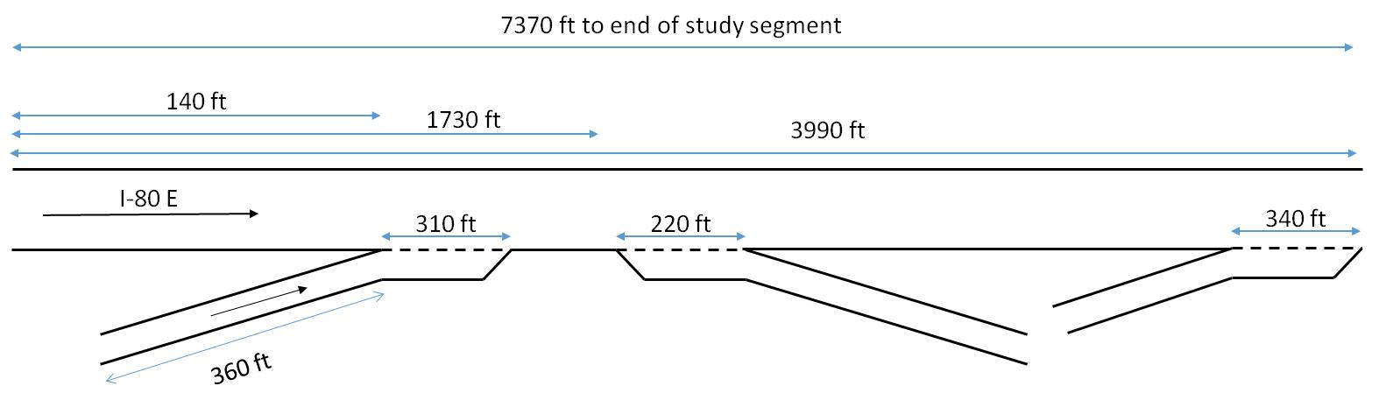I80-E geometric configuration:

Crash and detector data is for the section of I-80 E located between the Powell St. on-ramp detector (post-mile 3.89) and the N. Aquatic Park detector (post-mile 5.25), which stretches 1.36 miles. In addition to the on-ramp at the beginning of the roadway segment, the Ashby Ave. off-ramp and Ashby Ave. on-ramp are located 0.3 and 0.7 miles from the starting location, respectively. The section of the roadway from the start to the Ashby Ave. off-ramp has six lanes and after the exit there are five lanes in the eastbound direction. A figure of the subject roadway layout can be seen in the figure.